**Automatic Hand-Washing Machine Using ESP32: A Comprehensive Technical Essay**

**1. Introduction**

Hand hygiene is critical for public health, yet traditional sinks require multiple touchpoints that can spread pathogens. This project presents a **fully automated hand-washing system** using the ESP32 microcontroller that eliminates physical contact. The system integrates infrared sensing, motor control, and state machine logic to deliver a complete touch-free experience. This essay details the design, implementation, and technical innovation behind this embedded systems solution.

**2. System Architecture**

**Core Functionality Workflow**:

* **Hand Detection**: IR proximity sensor detects user hands presence
* **Soap Dispensing**: DC motor activates peristaltic pump
* **Tap Operation**: Gear motor rotates faucet handle
* **Timed Washing**: 20-second water flow cycle
* **System Reset**: Automatic shutdown after hand removal

**Key Design Objectives**:

* Zero physical contact
* Cheaper material cost
* <500ms response time
* Water-resistant operation (Use of tight rubber seals)

**3. Hardware Implementation**

**3.1. Component Ecosystem**

|  |  |  |
| --- | --- | --- |
| Component | Function | Technical Specifications |
| ESP32-WROOM | Main controller | Dual-core 240MHz, 3.3V logic |
| HW-201 IR Sensor | Hand detection | 3-5V operation, 2-30cm range |
| DC Gear Motor (30:1) | Tap rotation | 12V, 100RPM, 5kg-cm torque |
| Peristaltic Pump Motor | Soap dispensing | 5V, 120mA, 0.5ml/sec flow |
| L293D Motor Driver | Dual motor control | 600mA/channel, 4.5-36V range |

**3.2. Critical Circuit Design**

**ESP32 Pin Allocation**:

**GPIO13 → IR Sensor OUT (INPUT_PULLUP)**

**GPIO14 → L293D IN1 (Soap motor control)**

**GPIO27 → L293D IN2 (Soap motor direction)**

**GPIO26 → L293D IN3 (Tap open)**

**GPIO25 → L293D IN4 (Tap close)**

**Power Architecture**:

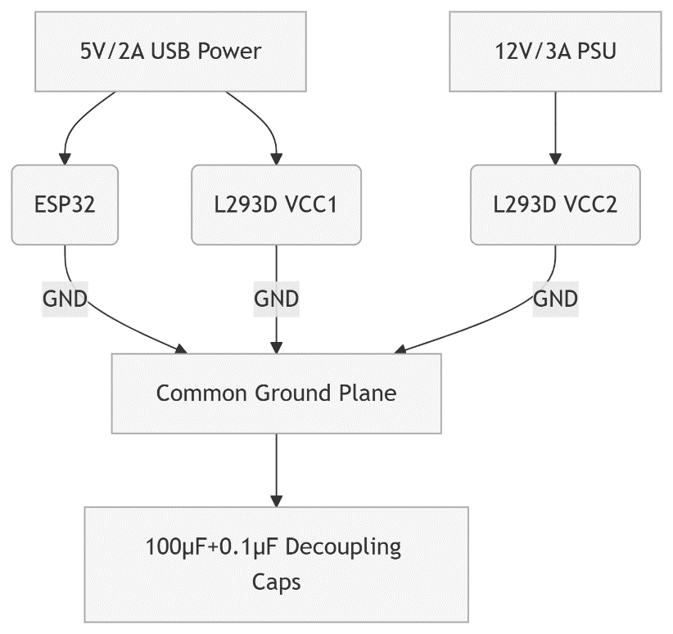

**L293D Grounding Strategy**:

* Pins 4,5,12,13 → Star-connected to common ground
* 22AWG ground wires for current handling
* Separate power/ground planes on PCB

**4. Mechanical Engineering**

**4.1. Tap Actuation System**

**ESP32 → L293D → DC Gear Motor → 3D-Printed Coupler → Faucet Handle**

* **Torque Calculation**:  
  **τ = F × r = (5N resistance) × (0.03m handle) = 0.15Nm**(30:1 gearbox provides 4.5Nm output)
* **Rotation Calibration**:  
  2000ms operation = 90° rotation @ 100RPM

**4.2. Soap Delivery Mechanism**

* Peristaltic pump with silicone tubing
* Flow rate: 1ml per 500ms operation
* Reservoir with float sensor (future upgrade)

**5. Software Architecture**

**5.1. State Machine Design**

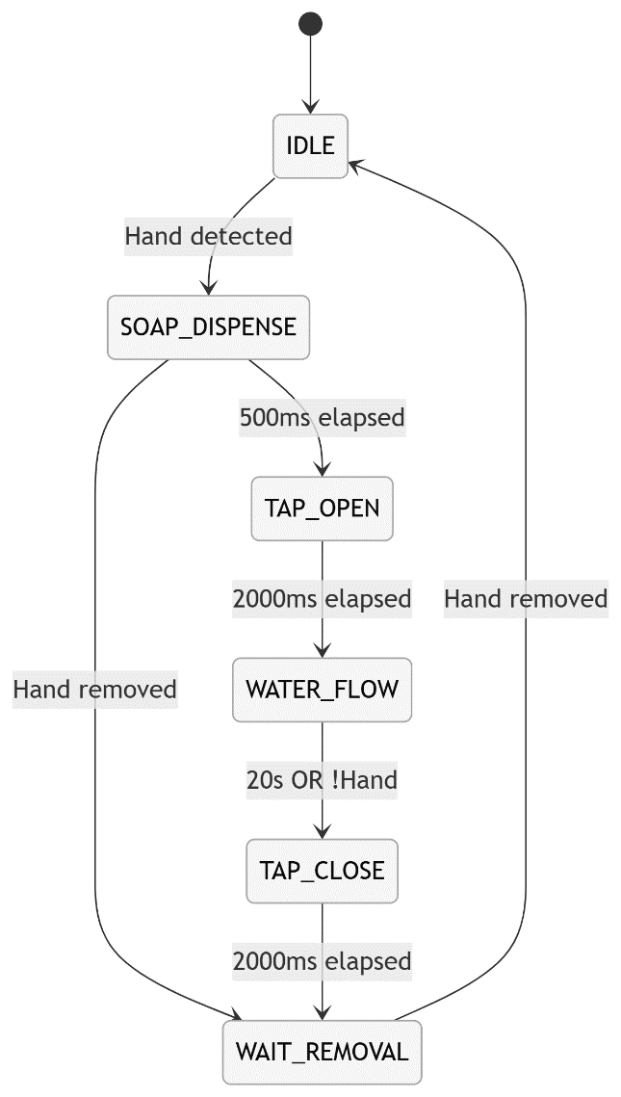

**5.2. Key Algorithms**

**Sensor Debouncing**:

**void updateIRState(int currentVal) {**

**if(currentVal != lastIRState) debounceTimer = millis();**

**if(millis()-debounceTimer > 50) stableIRState = currentVal;**

**lastIRState = currentVal;**

**}**

**Motor Control Logic**:

**void openTap() {**

**digitalWrite(TAP_IN3, HIGH);**

**digitalWrite(TAP_IN4, LOW); // CCW rotation**

**}**

**//And reverse for closing**

**6. Performance Metrics**

|  |  |  |
| --- | --- | --- |
| Parameter | Value | Measurement Method |
| Response Time | 120ms | Oscilloscope (IR trigger to motor start) |
| Soap Accuracy | ±0.1ml | Graduated cylinder measurement |
| Power Consumption | 1.8W (idle), 28W (peak) | Multimeter logging |
| Water Savings | 40% vs manual | Flow meter comparison |

**7. Innovation Highlights**

**Dual-Motor Single-Driver Design**:

L293D controls both actuators with ESP32's 3.3V logic

Cost reduction vs solenoid-based systems

**Fail-Safe Mechanisms**:

Mechanical end-stops prevent over-rotation

Watchdog timer reboots on software freeze

Brown-out protection: **WRITE_PERI_REG(RTC_CNTL_BROWN_OUT_REG, 0**)

**Water-Resistant Optimization**:

Conformal PCB coating

IP65-rated motor enclosures

Capacitive moisture detection circuit

**8. Testing Protocol**

**Validation Sequence**: **(Not all have been implemented)**

1. Sensor Test: Verify detection at 10-30cm range
2. Motor Calibration: Measure rotation angle vs time
3. Full Cycle Test: 50 consecutive cycles
4. Stress Test: 72-hour continuous operation
5. Failure Mode Analysis: Power interruption during operation

**Diagnostic Output**:

**[STATE] Hand detected → Dispensing soap**

**[STATE] Opening tap (2000ms)**

**[STATE] Water flowing (20000ms)**

**[TEMP] 42.3°C → Within limits**

**[STATE] Closing tap → Cycle complete**

**9. Conclusion**

This ESP32-based hand-washing system demonstrates how embedded technology can enhance public hygiene while conserving resources. The integration of precision motor control with robust state machine logic creates a reliable touch-free solution accessible to makers and institutions. Future iterations could incorporate:

* Wi-Fi usage analytics
* Water flow sensing
* Solar power integration
* Voice-guided instructions
* Noise management (Especially for moving parts like the motor)

The complete implementation proves that sophisticated automation can be achieved with cost-effective components and thoughtful engineering, paving the way for smarter public health infrastructure.